MIDTOWNERS SUNSHINE OF THE WEEK ► January 4, 2008
No Sunshine. Yet another cold and foggy morning

SPEAKER OF THE WEEK ► Dr. Saurav Dev Bhatta
THEME | Deadly sins of Statistical Misrepresentation in the Media
Come enjoy an interesting talk on how media can twist statistics to convey varying messages. Dr. Bhatta will enlighten us on some of the common misrepresentations displayed the media that we need to be aware of, and how we can discern them as readers.
Dr. Bhatta earned his PhD in City and Regional Planning from Cornell University, and was an assistant professor at the University of Illinois at Chicago from 2000 till the summer of 2007. He was Visiting Associate Professor in Urban Planning Program at Institute of Engineering, TU from 2003 till 2005. Dr. Bhatta is currently involved in the education sector in Nepal. He also holds a Masters in Electrical Engineering from MIT in Cambridge, MA.
Dr. Bhatta has extensive research experience in economics, education, development, social policy, and poverty and inequality. He has consulted for organizations such as Winrock International, DANIDA, National Planning Commission.

UPCOMING SPEAKERS ► PREVIEW
DATE | SPEAKER | THEME
Jan 25th | Chandra Morgan | Experience as exchange student in Nepal
Feb 1st | Vacant | Vacant
Feb 8th | Vacant | Vacant

THE MID-TOWN CLUB ► NEWS
Scenes from Last Week’s Club meeting
Ms. Isabelle Pastor informed the meeting about the activities of Schechen Clinic in Bouddha. The Clinic offers both physical and mental health services with 51,000 consultations recorded in 2006. It has Tibetan as well as Allopathic Medical Clinics that offers GP/ Medical/ RH service. There is also a lot of focus on inter-sectoral collaboration, appropriate technology, prevention, promotion at the clinic. She also talked about how Hospice and palliative care as well as social services are important part of the clinic. The clinic maintains a high standard of cleanliness.

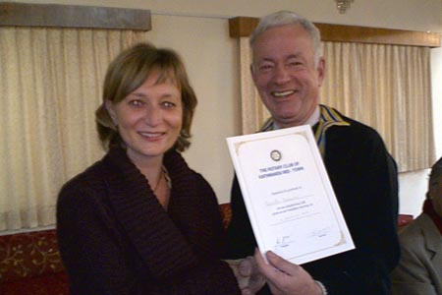  President Walter handing letter of appreciation to Guest Speaker Isabelle Pastor | 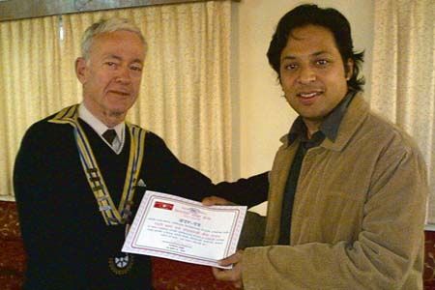  Dr. Suman Thapa handing letter of appreciation to our Club on behalf of Til Ganga Eye Hospital
ROTA QUIZ 2008 Finals
The finals of the Rota Quiz competition will be held on Saturday, January 19th at 8:30AM in Soaltee Hotel. The quiz team under the leadership of PP Ajaya are actively preparing for the finals. Please show up in mass to cheer for the Mid-Town team as they try to defend the title. Here are the finalists:
RC Kathmandu Mid-Town
RC Patan Durbar Square
RC Tripureswore
RC Narayanghat
RC Pokhara Mid-Town
RC from Biratnagar (not sure which one)

THE ROTARY INTERNATIONAL ► NEWS


Rotary International President-elect Dong Kurn Lee addressed incoming district governors today at the 2008 International Assembly, urging them to use their resources to help curb child mortality. Lee said he was in disbelief when he learned that 30,000 children under the age of five die every day from preventable diseases such as pneumonia, measles, and malaria. He challenged the audience to do their part to give children "hope and a chance at a future" by reducing the rate of child mortality in the world.
He told the incoming governors that Rotary will keep the service emphases of recent years -- water, health and hunger, and literacy -- but asked them to focus their efforts in each of these areas on children.
"In 2008-09, I will ask you all to Make Dreams Real for the world's children," he said. "This will be our theme, and my challenge to all of you."
"Children are killed by illnesses that become deadly in combination with poor sanitation and malnutrition," Lee said. In addition, families stricken by extreme poverty are trapped in a cycle that only leads to more unnecessary deaths. "It's a cycle that is not interrupted because there is no access to education."
"We will bring clean water to their communities and create sanitation projects that keep children healthy," Lee said. Rotarians can improve children's health, Lee said, even in small ways, such as delivering mosquito nets, rehydration salts, vitamins, and vaccines. "So much more can be done with just a little more: a trained birth attendant, a simple clinic, a school feeding program, a visiting nurse," he continued. "These are simple and direct ways to save children's lives."
In 2008-09, Rotarians will be asked to open their eyes to the needs of children in communities near and far, Lee said. "Children die not because nobody can help them, but because too often, nobody does. But you and I, here in this room, are Rotarians, and helping is what we do best," he said, adding that "our job is to Make Dreams Real for children. If every one of us does this, at the end of our year, we will all have achieved something wonderful."
By Ryan Hyland
Rotary International News - 14 January 2008

Editor: Rabi Karmacharya, Club Service Director email: rabikarma@gmail.com

----- Original Message -----
From: "Rabi Karmacharya" <rabikarma@gmail.com>
To: <undisclosed-recipients:>
Sent: 17 January, 2008 17:35
Subject: BC Vol 18 07-08

Dear Mid-Towners.
Here is the latest BC. Hope to see more of you at the meeting tomorrow.
Come enjoy an interesting talk on how media can twist statistics to
convey varying messages. Our guest speaker Dr. Saurav Dev Bhatta will
enlighten us on some of the common misrepresentations displayed the
media that we need to be aware of, and how we can discern them as readers.
Also, the finals of Rota Quiz will take place on Saturday, January 19th
at 8:30AM at Soaltee Hotel. We would like to see a large number of
Mid-Towners in the audience cheering for our team.
YIR,
-Rabi
CSD RC KTM Mid-Town 2007-08

